Report:
The website is going to be a very simple website that is going to be representing the football team called Real Madrid. It is going to have 6 pages. Those pages are going to be the Home page, News page, Players page, Records page, Trophies page and History page. The targeted audience is towards all the people that enjoy football and also for those that are just starting to watch football. With this website I would like to introduce those people to Real Madrid and also expand the knowledge to the people that already know something about Real Madrid.

Website Hierarchy:

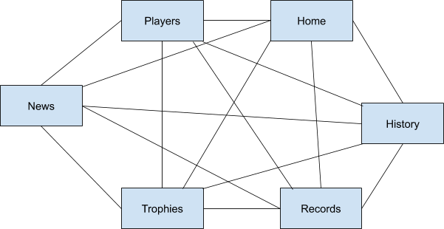

Link to the website:
Real Madrid (bucks.ac.uk)

